Agentic Energy Optimization & Demand Response System-Agentic AI( Claude Sonnet 4.5)

Project Description:
The Agentic Energy Optimization & Demand Response System applies agentic AI to reduce electricity costs and peak demand in commercial buildings without disrupting daily operations. The platform includes a Demand Forecasting module, which uses a time-series machine learning model to project building electricity consumption up to four hours ahead; a Strategy Generation & What-If Simulation module, which uses an LLM reasoning engine to propose and evaluate multiple peak-shaving strategies before any action is taken; and a Human-in-the-Loop Execution module, which routes high-impact control actions through facility-manager approval before dispatching them to the building's systems.
Built with Python, LangGraph, and Anthropic's Claude models for autonomous reasoning, the system continuously monitors simulated IoT telemetry — occupancy, indoor/outdoor temperature, electricity pricing, and equipment state — sourced from a custom-built building simulator. A FastAPI backend exposes the agent as a set of REST endpoints, and an interactive Plotly dashboard visualizes live demand, forecasts, candidate strategies, and cumulative cost savings. With safety-bounded control tools and full action auditing, the system empowers facility managers to safely delegate day-to-day peak-demand decisions to an autonomous agent while retaining final approval authority.

Scenarios
Scenario 1: An office building's demand forecast shows consumption climbing toward 145 kW during the 2–5 PM high-tariff window. The agent detects the risk, generates three candidate strategies (pre-cooling with setpoint drift, aggressive battery and lighting shaving, flexible load shifting), simulates each against the forecasting model, and presents its top two ranked options to a facility manager, who approves the top-ranked plan — reducing peak-window energy use by 13.2% and projecting $66.82 in savings.
Scenario 2: On a mild weekday, forecasted demand stays below the intervention threshold. The agent completes its monitor → forecast → diagnose cycle, determines no peak risk exists, and returns to standby without generating any strategies or requiring human approval — demonstrating that the system escalates only when intervention is genuinely warranted.
Scenario 3: A facility manager rejects both proposed strategies as too aggressive. The agent incorporates this feedback and regenerates a new, more conservative batch of candidates (lower setpoint drift, gentler dimming). If this second batch is also rejected, the workflow safely terminates with zero control actions taken rather than looping indefinitely.

Technical Architecture:
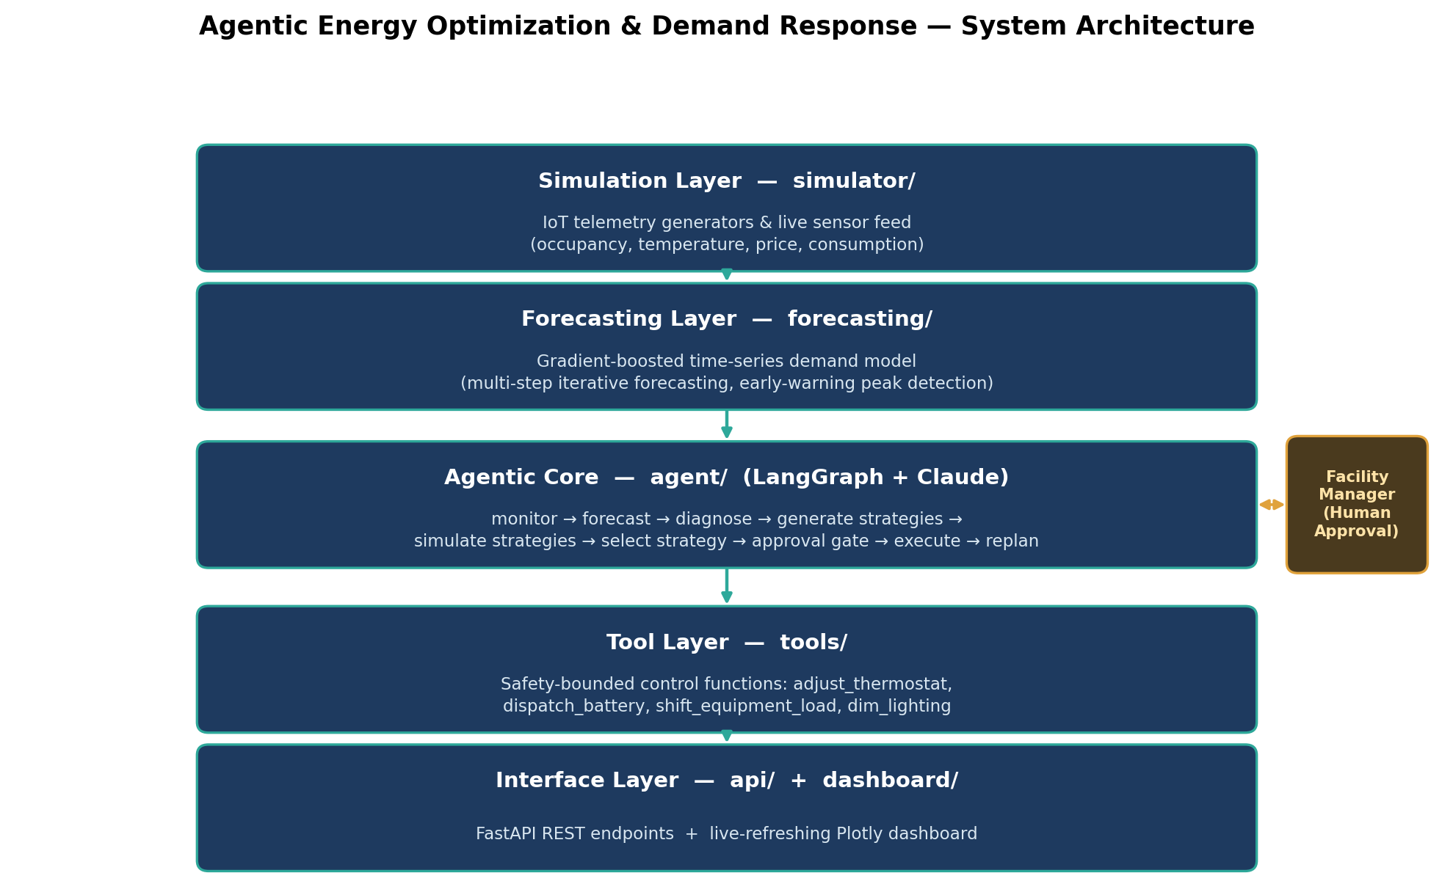

Description:
The system uses a five-layer architecture. A Simulation Layer (simulator/) generates realistic synthetic IoT telemetry — occupancy, temperature, consumption, and time-of-use electricity pricing — standing in for real building sensors and control systems, including a live-feed class that responds to control actions in real time. A Forecasting Layer (forecasting/) trains a gradient-boosted time-series model on historical telemetry to project demand several hours ahead, validated with both single-step and iterative multi-step accuracy checks. The Agentic Core (agent/), built with LangGraph, orchestrates a nine-node state graph — monitor, forecast, diagnose, generate strategies, simulate strategies, select strategy, human approval gate, execute actions, and replan check — using Anthropic's Claude models for strategy generation and structured reasoning. A Tool Layer (tools/) exposes safety-bounded, typed functions (thermostat adjustment, battery dispatch, load shifting, lighting control) that the agent calls to affect the simulated building, with every action logged for audit. Finally, an Interface Layer (api/ and dashboard/) exposes the agent via FastAPI REST endpoints and a live-refreshing Plotly dashboard for monitoring and approval.

Pre-requisites:
- Python Programming Proficiency: Python Documentation — docs.python.org/3/
- LangGraph & LangChain Familiarity: LangGraph Documentation — langchain-ai.github.io/langgraph/
- Anthropic Claude API Familiarity: Claude API Documentation — docs.claude.com
- Time-Series & Machine Learning Basics: scikit-learn Documentation — scikit-learn.org/stable/
- FastAPI Framework Knowledge: FastAPI Documentation — fastapi.tiangolo.com
- Data Handling with Pandas / NumPy: Pandas Documentation — pandas.pydata.org/docs/
- Data Visualization with Plotly: Plotly Documentation — plotly.com/python/
- Version Control with Git: Git Documentation — git-scm.com/docs/git

Project Workflow:

Milestone 1: Model Selection and Architecture
- Activity 1.1: Generate an Anthropic API key and configure it securely in the project environment.
- Activity 1.2: Research and select the appropriate generative AI model and forecasting approach for building energy optimization.
- Activity 1.3: Define the architecture of the application, detailing interactions between the simulation, forecasting, agentic core, tool, and interface layers.
- Activity 1.4: Set up the development environment, installing the necessary libraries and dependencies for LangGraph, FastAPI, and the Claude API.

Milestone 2: Core Functionalities Development
- Activity 2.1: Develop the core functionalities: IoT data simulation, the live sensor feed, the demand forecasting model, and safety-bounded building control tools.
- Activity 2.2: Implement the tool layer to manage safe control-action execution and audit logging, ensuring reliable interaction with the simulated building.

Milestone 3: App.py Development
- Activity 3.1: Write the core agent orchestration logic, establishing the LangGraph state graph, node functions, and conditional routing that integrate forecasting, strategy generation, and execution, and expose it through a FastAPI backend.

Milestone 4: Frontend Development
- Activity 4.1: Design and develop the monitoring dashboard using Plotly, ensuring a responsive and intuitive layout for live telemetry, forecasts, and pricing.
- Activity 4.2: Create the strategy approval panel and action log views, enabling human-in-the-loop decision-making directly from the dashboard.

Milestone 5: Deployment
- Activity 5.1: Prepare the application for local deployment by configuring the server environment and ensuring all dependencies are correctly installed.
- Activity 5.2: Deploy the FastAPI application locally, and optionally expose it publicly via Ngrok, to make the dashboard and agent endpoints accessible for testing.

Milestone 6: Conclusion
Milestone 1: Model Selection and Architecture

In this milestone, we focus on selecting the appropriate generative AI model and forecasting approach for the energy optimization agent. This involves researching Claude's reasoning and structured-output capabilities for strategy generation, and a suitable time-series model for demand forecasting, ensuring both align with the application's objective of detecting and safely mitigating afternoon peak-demand risk.

Activity 1.1: Generate an Anthropic API Key
Before the agent can reason about strategies using Claude, a valid Anthropic API key is required. Follow the steps below to create one and connect it securely to the project.
- Step 1 — Create an Anthropic Account: Visit console.anthropic.com and sign up for an account.
- Step 2 — Navigate to API Keys: From the console, open the “API Keys” section under account settings.
- Step 3 — Create a New API Key: Click “Create Key” and give it a descriptive name (e.g. energy-agent-key) so it is easy to identify later.
- Step 4 — Copy the Key: Copy the key immediately and store it safely — it cannot be viewed again after the dialog closes.
- Step 5 — Add the Key to the Project: Create a .env file in the project root and add the key as shown below.
from dotenv import load_dotenv
load_dotenv()

from langchain_anthropic import ChatAnthropic
llm = ChatAnthropic(model="claude-sonnet-4-6", temperature=0.3)
The agent loads this key automatically at startup using python-dotenv:
ANTHROPIC_API_KEY=your_copied_api_key_here
- Important — Never Commit the API Key: Add .env to .gitignore to prevent accidentally pushing the key to a public repository.

Activity 1.2: Research and Select the Appropriate Models
- Understand the Project Requirements: review the specific reasoning needs of the agent — generating structured, multi-candidate demand-response strategies, and forecasting building electricity consumption several hours ahead.
- Explore Model Documentation: examine Claude's structured-output and tool-use capabilities for the strategy-generation node, and scikit-learn's regression models for the forecasting layer.
- Evaluate Model Performance: compare LLM options on structured JSON reliability and reasoning quality for operational planning; compare forecasting approaches (gradient boosting vs. Prophet) on iterative multi-step accuracy over a 3–4 hour horizon.
Select the Optimal Models: Use a Claude model via langchain-anthropic for the reasoning engine, prompted to return structured Pydantic-validated strategy proposals. Use a GradientBoostingRegressor from scikit-learn for demand forecasting, trained on lag, rolling-window, and time-of-day features, and validated against both single-step and true iterative multi-step forecasts — the latter being the realistic test of the agent's early-warning capability.

Activity 1.3: Define the Architecture of the Application
- Draft an Architectural Diagram: create a visual representation of the five-layer architecture — simulation, forecasting, agentic core, tool layer, and interface layer (see Technical Architecture above).
- Detail Simulation Layer Functionality: outline how synthetic telemetry is generated and how the live sensor simulator responds to control actions in real time.
- Outline Agentic Core Responsibilities: specify the LangGraph state graph's nine nodes and their conditional routing, including the human-approval interrupt/resume mechanism.
- Describe AI Integration Points: define how the generate_strategies node constructs prompts from current state and forecast data, requires structured Pydantic output, and how the diagnose and simulate_strategies nodes call the forecasting model.

Activity 1.4: Set Up the Development Environment
- Install Python and Pip: ensure Python 3.10+ is installed along with pip for dependency management.
- Create a Virtual Environment: set up a virtual environment to isolate project dependencies.
requirements.txt includes: pandas, numpy, fastapi, uvicorn, plotly, langgraph, langchain, langchain-anthropic, scikit-learn, pydantic, python-dotenv, httpx, pytest.
- Configure the API Key: create a .env file in the project root and add the Anthropic API key as shown in Activity 1.1.
- Set Up the Project Structure: create the directory structure — simulator/, forecasting/, agent/, tools/, api/, dashboard/, tests/, and data/ — with an empty __init__.py in each Python package folder.
python -m venv venv
source venv/bin/activate # (venv\Scripts\activate on Windows)
pip install -r requirements.txt

Milestone 2: Core Functionalities Development

Activity 2.1: Develop Core Content Generation Features
Implement the four core simulation and prediction capabilities — IoT Data Generation, Live Sensor Feed, Demand Forecasting, and Building Control Tools — as the operational foundation the agent reasons and acts upon.
- IoT Data Simulation: generates 15-minute-resolution synthetic telemetry — occupancy following a weekday office pattern, a sinusoidal outdoor temperature curve, time-of-use electricity pricing with a clear 2–5 PM peak rate window, and total consumption modeled from occupancy, HVAC thermal load, and a base load — verified to peak between 2–5 PM as required by the scenario.
- Live Sensor Feed: a LiveBuildingSensor class maintaining state across three thermal zones, battery storage, and equipment deferrals, which advances realistically on each tick and immediately reflects control actions (e.g. raising a thermostat setpoint visibly reduces HVAC draw on the next reading).
- Demand Forecasting: a GradientBoostingRegressor trained on lag, rolling-mean, and time-of-day features, evaluated with a true iterative multi-step forecast (not single-step nowcasting) anchored at 1:00 PM and projected out to 5:00 PM — achieving a 100% early-warning detection rate for weekday peaks exceeding the configured 110 kWh threshold in testing.
- Building Control Tools: typed, safety-bounded functions — adjust_thermostat, shift_equipment_load, dispatch_battery, and dim_lighting — each validated against operational safety limits (19–26°C setpoints, protection of critical equipment such as server cooling and life-safety systems, battery power/state-of-charge limits, and a minimum lighting floor).

Activity 2.2: Implement the Tool & Audit Layer
- Define Typed Inputs and Outputs: represent every control action and its result with Pydantic models (ActionResult, BuildingState, CostEstimate) so each function can later be exposed directly as a LangGraph tool.
- Enforce Safety Checks: reject out-of-bounds requests (e.g. a thermostat setpoint outside 19–26°C, or a delay applied to critical equipment) with a clear rejection reason rather than silently failing.
- Estimate Cost Impact: provide an estimate_cost_impact() function that projects the $ savings or cost of a proposed action over the next hour, using the current electricity price and the forecasting module.
- Audit Every Action: log every accepted and rejected action — with timestamp, parameters, success flag, reason, and cost impact — to data/action_log.csv.
def adjust_thermostat(zone: str, new_setpoint_c: float) -> ActionResult:
if not (19.0 <= new_setpoint_c <= 26.0):
return ActionResult(success=False,
reason=f"REJECTED: Setpoint {new_setpoint_c}°C violates safety "
f"boundary (allowed range: 19.0–26.0°C).")
sensor.set_thermostat(zone, new_setpoint_c)
result = ActionResult(success=True,
reason=f"SUCCESS: Thermostat for zone '{zone}' set to {new_setpoint_c}°C.")
log_action("adjust_thermostat", locals(), result)
return result

Milestone 3: App.py Development

Milestone 3 focuses on building the core orchestration logic that ties the simulation, forecasting, and tool layers into a single autonomous agent, and on exposing that agent through a FastAPI backend — the backbone of the entire application, analogous to a traditional app.py entry point.

Activity 3.1: Writing the Core Application Logic
Define the Shared Agent State:
class EnergyAgentState(TypedDict):
current_building_state: dict
forecast: list
risk_detected: bool
candidate_strategies: list
simulation_results: list
selected_strategy: dict
ranked_strategies: list
requires_human_approval: bool
approval_status: str
executed_actions: list
cost_savings_estimate: dict
replan_count: int
should_continue: bool
messages: Annotated[list, add_messages]

Build the LangGraph State Graph and Conditional Routing:
graph = StateGraph(EnergyAgentState)
graph.add_node("monitor", monitor_node)
graph.add_node("forecast_demand", forecast_demand_node)
graph.add_node("diagnose", diagnose_node)
graph.add_node("generate_strategies", generate_strategies_node)
graph.add_node("simulate_strategies", simulate_strategies_node)
graph.add_node("select_strategy", select_strategy_node)
graph.add_node("human_approval_gate", human_approval_gate_node)
graph.add_node("execute_actions", execute_actions_node)
graph.add_node("replan_check", replan_check_node)

graph.add_conditional_edges("diagnose", route_after_diagnose,
{"risk": "generate_strategies", "no_risk": "replan_check"})
graph.add_conditional_edges("human_approval_gate", route_after_approval,
{"approved": "execute_actions", "retry": "generate_strategies",
"safe_stop": "replan_check"})
graph.add_conditional_edges("replan_check", route_after_replan,
{"continue": "monitor", "done": END})

Implement Structured Strategy Generation:
class ProposedAction(BaseModel):
action_type: str
parameters: dict

class CandidateStrategy(BaseModel):
strategy_name: str
actions: list[ProposedAction]
expected_kw_reduction: float
rationale: str

class StrategyGenerationOutput(BaseModel):
strategies: list[CandidateStrategy]

structured_llm = llm.with_structured_output(StrategyGenerationOutput)

Implement Weighted Strategy Scoring:
score = (COST_WEIGHT * normalized_savings) - (COMFORT_WEIGHT * normalized_comfort_deviation)
# Defaults: COST_WEIGHT = 0.5, COMFORT_WEIGHT = 0.5 (configurable in agent/config.py)

Implement the Human Approval Gate with Alternative Selection and a Bounded Retry:
def route_after_approval(state):
if state["approval_status"] == "approved":
return "approved"
if state["approval_status"] == "rejected":
if state["replan_count"] >= 1:
return "safe_stop" # cap reached: end run, 0 actions taken
state["replan_count"] += 1
return "retry" # regenerate a genuinely different batch

Expose the Agent via FastAPI Routes:
@app.get("/building/state")
def building_state():
return get_current_building_state()

@app.get("/forecast")
def forecast(hours: int = 3):
return forecast_next_hours(get_history(), hours_ahead=hours)

@app.post("/agent/run")
def run_agent(payload: RunRequest):
run_id = new_run_id()
result = energy_graph.invoke({}, config={"configurable": {"thread_id": run_id}})
return format_run_response(run_id, result)

@app.post("/agent/approve")
def approve_agent(payload: ApproveRequest):
# payload: run_id, approved: bool, chosen_strategy_id: Optional[str], notes
result = energy_graph.update_state(
{"configurable": {"thread_id": payload.run_id}}, payload.dict())
return format_run_response(payload.run_id, result)

@app.get("/actions/log")
def actions_log(limit: int = 20):
return read_action_log(limit)

@app.get("/savings/summary")
def savings_summary():
return aggregate_savings()

Home route and application entry point:
app = FastAPI(title="Agentic Energy Optimization & Demand Response System")

if __name__ == "__main__":
import uvicorn
uvicorn.run("api.main:app", host="0.0.0.0", port=8000, reload=True)

Milestone 4: Frontend Development

Milestone 4 focuses on developing a clear, live-updating monitoring dashboard for the energy agent. This involves designing a dark, data-dense layout with Plotly charts for demand, price, and telemetry, and building an interactive approval panel so a facility manager can review and act on the agent's proposed strategies without leaving the dashboard.

Activity 4.1: Designing and Developing the Dashboard
- Set Up the Base Layout: build the dashboard as a single page with a header (system title, live-telemetry indicator, run/refresh controls), a KPI summary row, and a two-column body.
- KPI Summary Row: four cards showing current load & temperature, the current electricity tariff, the peak forecast for the next 3 hours with a risk flag, and cumulative cost savings.
- Energy Demand Forecast Chart: overlay historical/live demand, the forecasted demand curve, and electricity price on a shared timeline, with the 2–5 PM high-tariff window visually shaded so the peak is immediately visible rather than only implied by the data.
- Supporting Telemetry Chart: occupancy and outdoor temperature plotted together as context for why demand is rising.
- Cumulative Savings Chart: a bar chart of cost savings vs. an unmitigated baseline, tracked per simulated day.
- Auto-Refresh: poll the FastAPI endpoints (/building/state, /forecast, /savings/summary) on an interval so the dashboard behaves like a live monitoring tool.

Activity 4.2: Strategy Approval Panel & Action Log
- Render the Pending Proposal: when POST /agent/run returns a PENDING_APPROVAL payload, display the top-ranked and alternative strategies side by side, each with its projected savings, energy reduction, and comfort rating.
- Wire the Decision Buttons: “Approve Top Strategy,” “Approve Alternative,” and “Reject Strategy Proposal” each call POST /agent/approve with the corresponding run_id and chosen_strategy_id, and the panel updates to reflect the execution result.
- Render the Action Log Table: pull recent entries from GET /actions/log and display timestamp, action type, parameters, execution result, and cost impact for full auditability.
Milestone 5: Deployment

In Milestone 5, the focus is on deploying the Agentic Energy Optimization & Demand Response System first locally to verify correct operation, and then optionally exposing it publicly via Ngrok to share the running dashboard and API over a secure URL.

Activity 5.1: Preparing the Application for Local Deployment
Create and activate a virtual environment, then install all required dependencies:
python -m venv venv
source venv/bin/activate
(venv) $ pip install -r requirements.txt
Configure environment variables — create a .env file in the project root with the Anthropic API key, which the agent loads automatically at startup:
ANTHROPIC_API_KEY=your_anthropic_api_key_here

Activity 5.2: Local Testing and Verification
Start the FastAPI development server:
(venv) $ uvicorn api.main:app --reload --port 8000

- Once running, open a browser and navigate to http://127.0.0.1:8000/dashboard to access the monitoring dashboard.
- Trigger a full agent cycle from the dashboard and verify the monitor → forecast → diagnose → strategy generation → simulation → approval → execution flow completes correctly for both the approve-top and approve-alternative paths, and that rejecting all proposals safely terminates the run.
- Verify /building/state, /forecast, /actions/log, and /savings/summary all return correctly formatted JSON.

Activity 5.3: Public Deployment via Ngrok
Ngrok creates a secure tunnel from a public URL to the local FastAPI server, making the dashboard accessible from anywhere without a cloud hosting provider.
- Install the pyngrok Python wrapper, which manages Ngrok programmatically:
pip install pyngrok

- Sign up at ngrok.com and copy the authtoken from the Ngrok dashboard.
- Set the authtoken and open a tunnel to the Uvicorn server's port before or alongside starting the app.
from pyngrok import ngrok
ngrok.set_auth_token("YOUR_NGROK_AUTHTOKEN")
public_url = ngrok.connect(8000)
print(f"YOUR PUBLIC DASHBOARD URL IS LIVE: {public_url}")

Important Notes:
- Disable the auto-reloader (reload=False) when running behind an active Ngrok tunnel, as the reloader's process restarts can interfere with tunnel stability.
- On the free Ngrok plan, the public URL changes each time the tunnel is restarted; a paid plan with a reserved domain gives a persistent URL.
- Free-tier Ngrok sessions expire after a period of inactivity — restart the tunnel to get a new URL when this happens.

Exploring the Dashboard:

Main Monitoring Dashboard:
Description: The dashboard's main view is a dark, data-dense monitoring layout. A header displays the system title, a live-telemetry status indicator, and controls to run an agent cycle or refresh the view. Below it, a KPI row surfaces current load and temperature, the current electricity tariff, the peak forecast for the next three hours with a risk indicator, and cumulative cost savings. The main body is a two-column layout: the left column holds the demand-forecast chart (with the 2–5 PM tariff window shaded) and the supporting occupancy/temperature chart; the right column holds the strategy approval panel and the cumulative-savings bar chart. An audit log table spans the full width at the bottom.
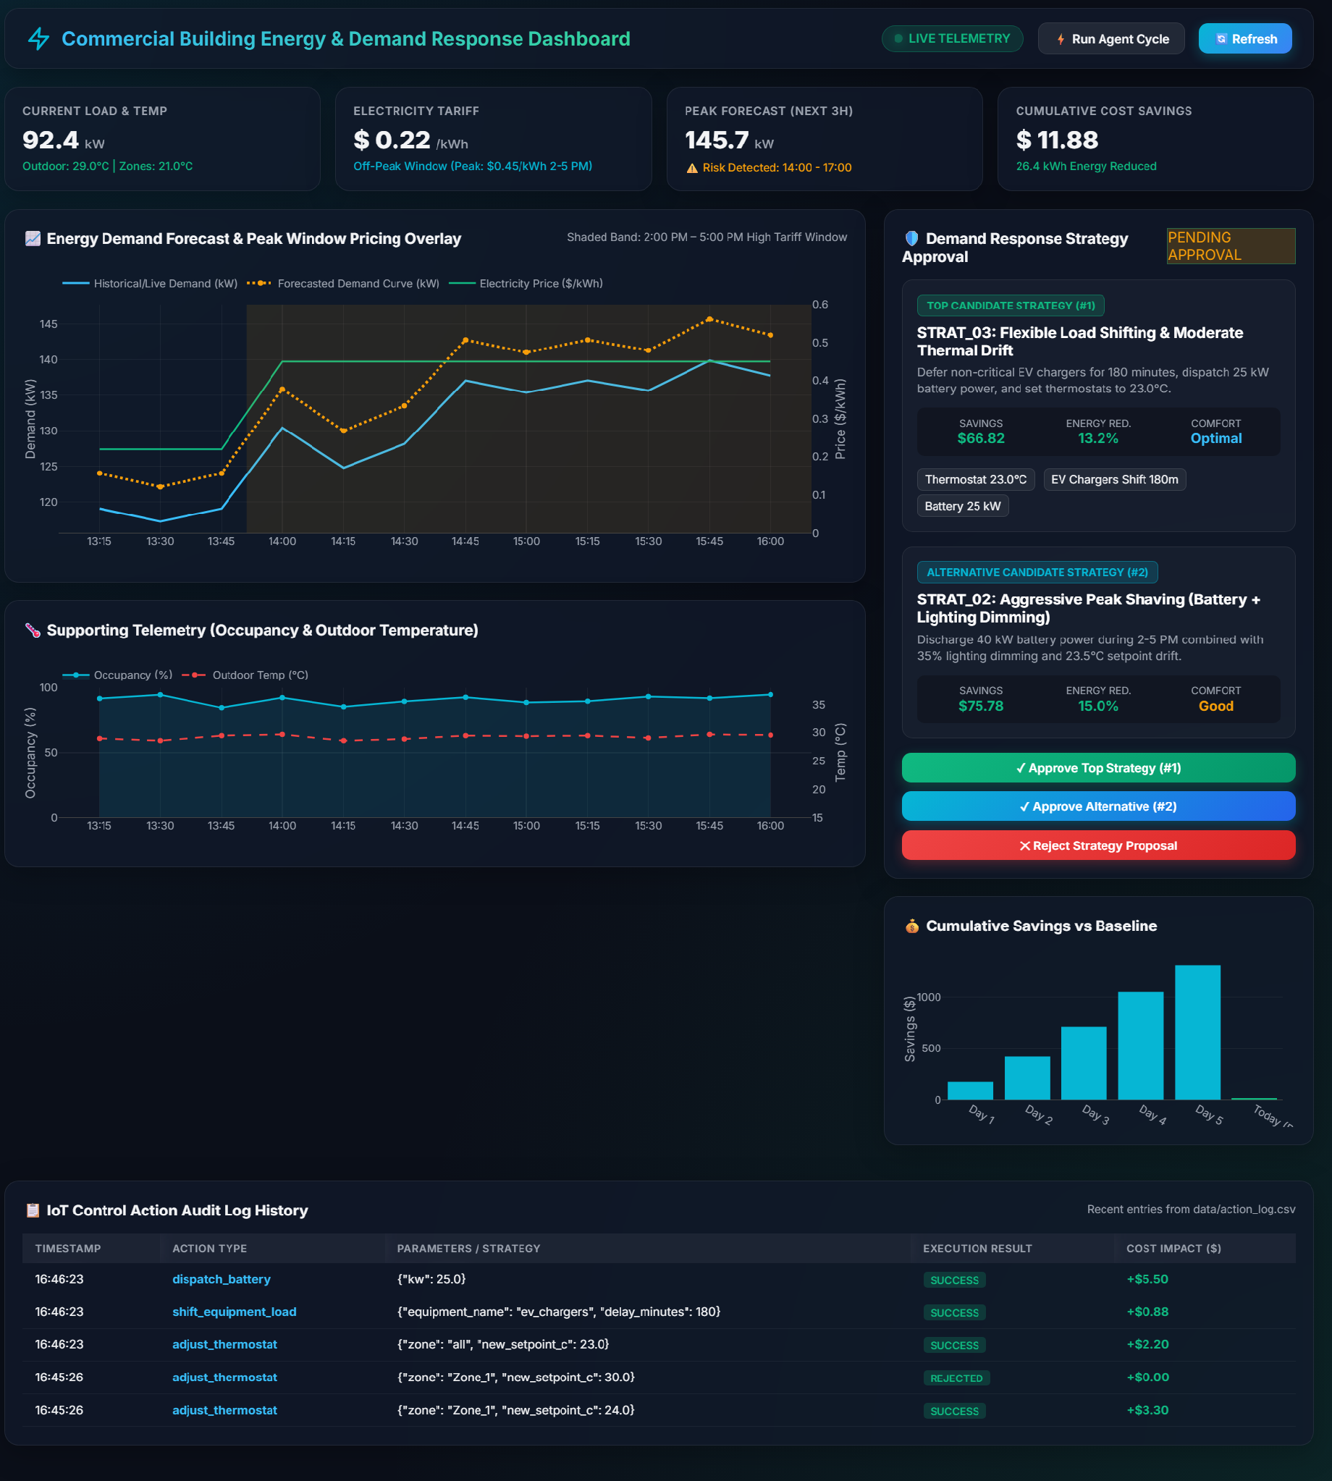

Demand Response Strategy Approval Panel:
Description: This panel is the dashboard's human-in-the-loop control point. It surfaces the agent's top-ranked candidate strategy and a ranked alternative side by side, each showing its projected dollar savings, energy-reduction percentage, and thermal-comfort rating, along with the specific control actions each would take (e.g. thermostat setpoint, EV-charger deferral, battery discharge rate). Three buttons — Approve Top Strategy, Approve Alternative, and Reject Strategy Proposal — let a facility manager act on the proposal directly from the dashboard, corresponding to a call to POST /agent/approve.
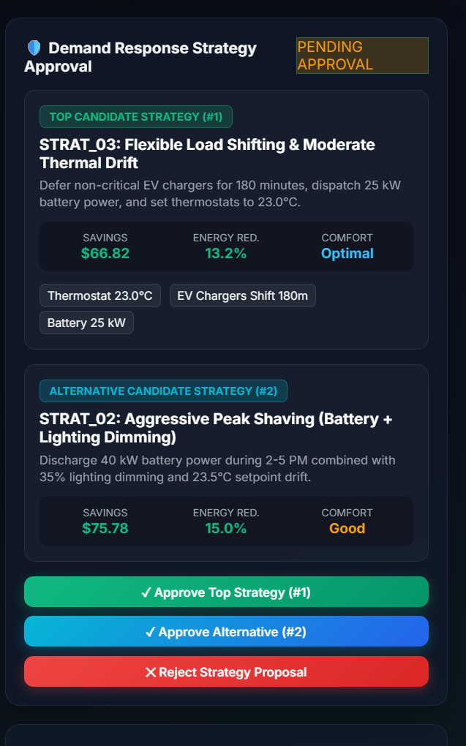

IoT Control Action Audit Log:
Description: A scrolling table at the base of the dashboard listing every control action the agent has dispatched to the simulated building — timestamp, action type, parameters, execution result, and dollar cost impact — sourced from data/action_log.csv via GET /actions/log. This view makes every decision the agent has acted on fully traceable after the fact. Note the rejected entry below: a request to set Zone_1 to 30.0°C was automatically blocked for violating the safety bounds, and a safe 24.0°C setpoint was applied immediately after — the safety layer enforcing its limits live, not only in isolated tests.
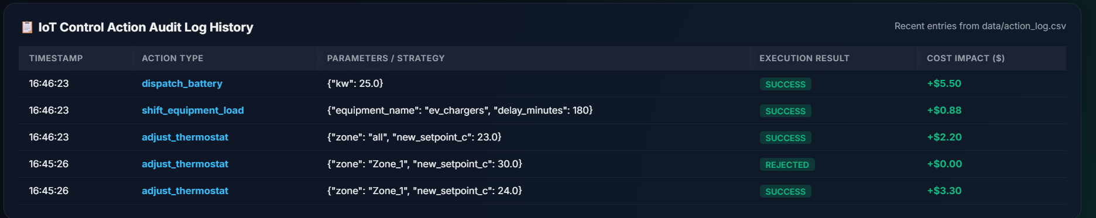

Conclusion:
The Agentic Energy Optimization & Demand Response System demonstrates how agentic AI — built with LangGraph and Anthropic's Claude models — can move beyond static, rule-based building automation to a closed loop of perceiving, forecasting, planning, simulating, and safely acting on real operational conditions. Across its development, the project validated each layer independently: a synthetic IoT simulator producing a realistic 2–5 PM demand and pricing peak; a forecasting model confirmed to hold up under true iterative multi-step evaluation rather than easier single-step nowcasting; a safety-bounded tool layer that rejects unsafe control requests outright; and an agentic core that generates genuinely distinct candidate strategies, evaluates them through what-if simulation, ranks them on a configurable cost-versus-comfort trade-off, and defers to human approval — including the ability to offer an alternative, adapt to a rejection with a materially different proposal, and safely terminate rather than loop indefinitely. The result, exposed through a FastAPI backend and a live Plotly dashboard, is a system that lets a facility manager delegate day-to-day peak-demand decisions to an autonomous agent while retaining full visibility and final approval authority.
Looking ahead, the system offers clear opportunities for expansion: integrating real building IoT and BMS APIs in place of the simulator, extending the forecasting model with weather-service inputs for greater accuracy, supporting multi-building portfolios with cross-building load balancing, and refining strategy scoring with reinforcement learning from accepted and rejected proposals over time. By continuing to strengthen the forecasting horizon and broadening the range of safe control actions available to the agent, the platform is well positioned to evolve from a demonstration system into a production-grade demand-response assistant for real commercial buildings.

